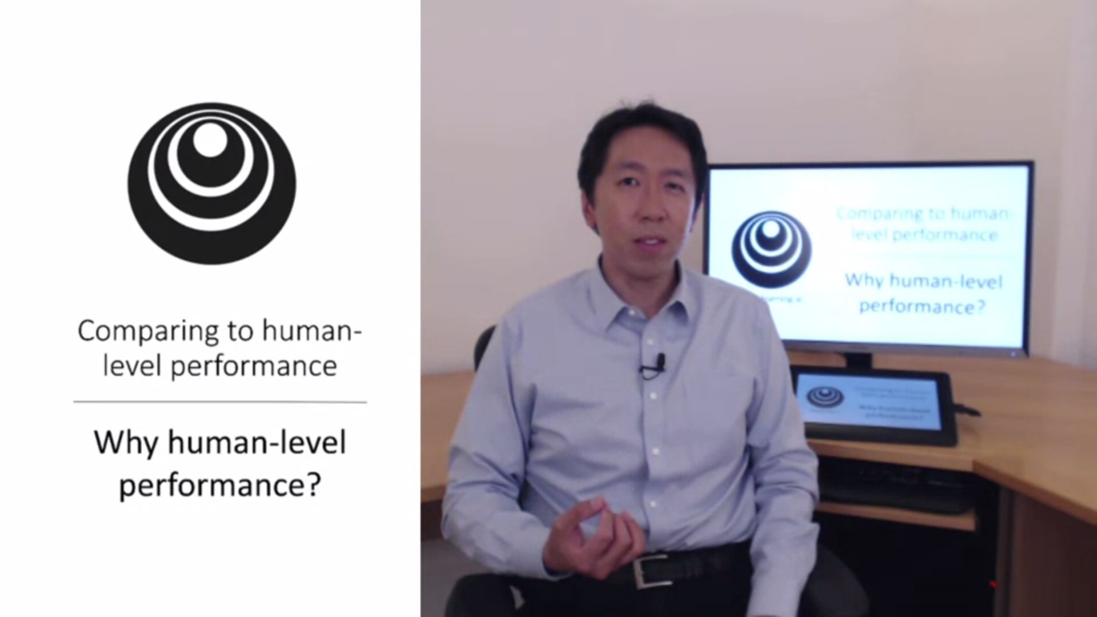In the last few years more and more ML teams have been talking about comparing their systems to human-level performance. Why is that?

Thanks to deep learning, algorithms are working much better.

Second, the workflow is much more efficient when you try to do something that humans can do.

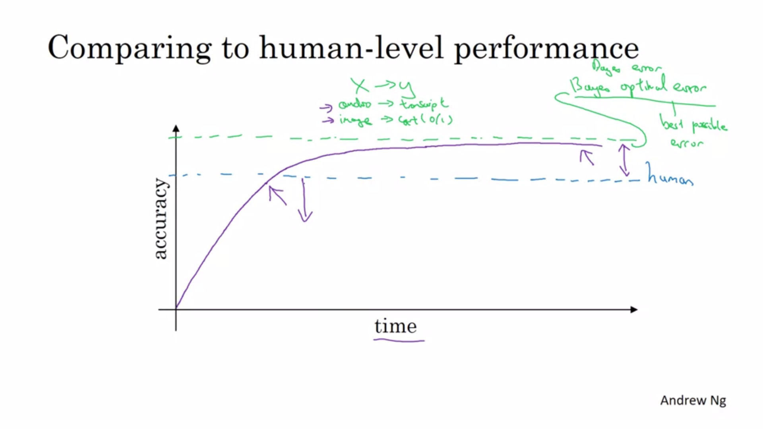

Progress is quite rapid until you achieve human-level performance. But then the slope goes down.

The performance never surpasses some theoretical limit which is called bayes optimal error. Think of this as the best possible error. There is just no way for any function to surpass this (e.g. audio could be so noisy that it is not possible to tell; other example blurry images).

There are two reasons for the slowing down of progress: Often human-level performance is close to bayes error and there is not much headroom to improve. The second reason is that there are tools to use when you are below human-level performance that you cannot use anymore once you surpass human performance. These are important tactics.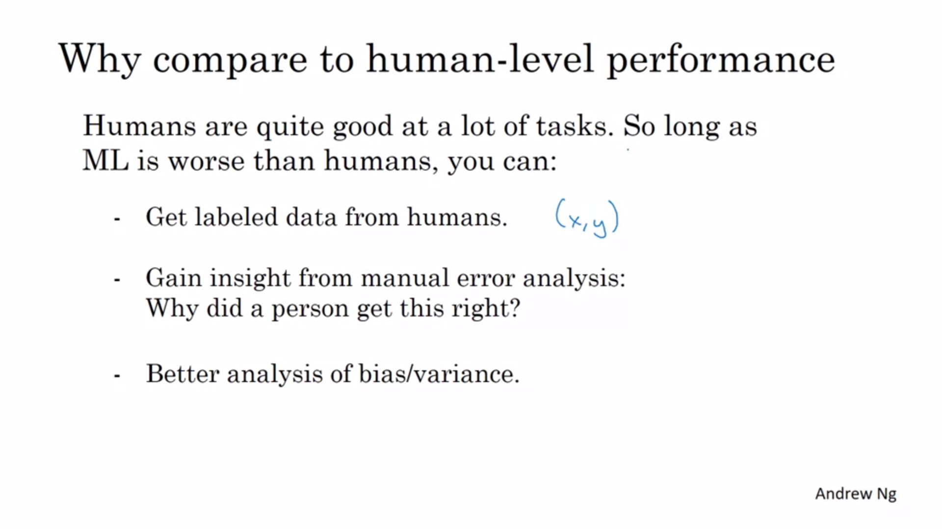

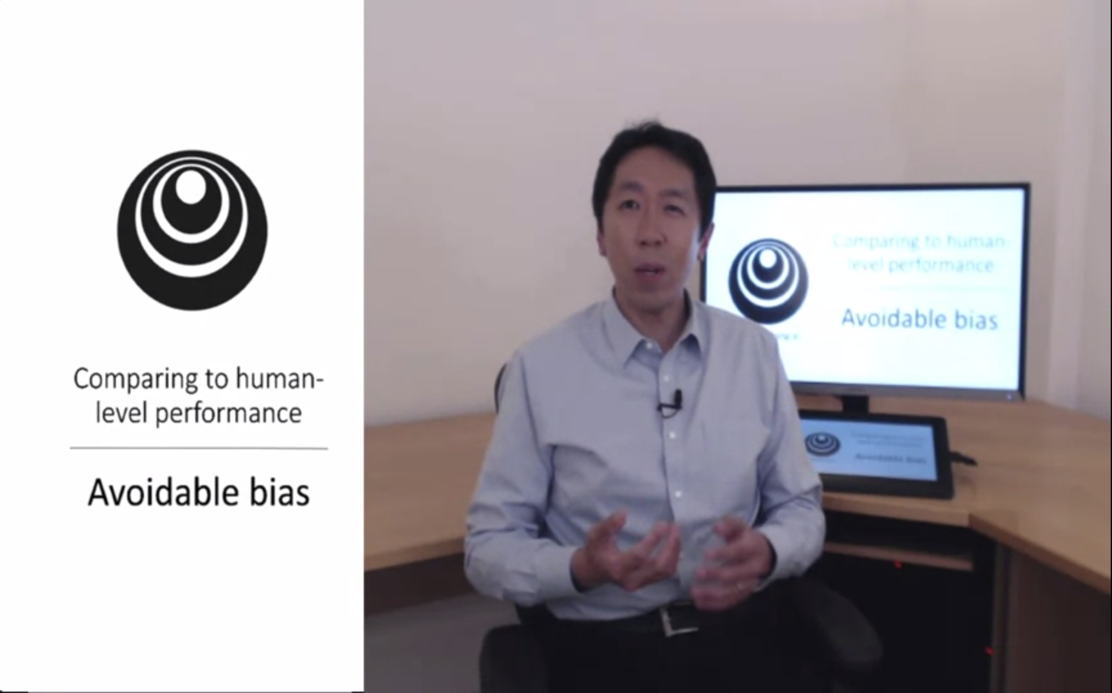

Knowing how humans do on a task can help you to understand avoidable bias.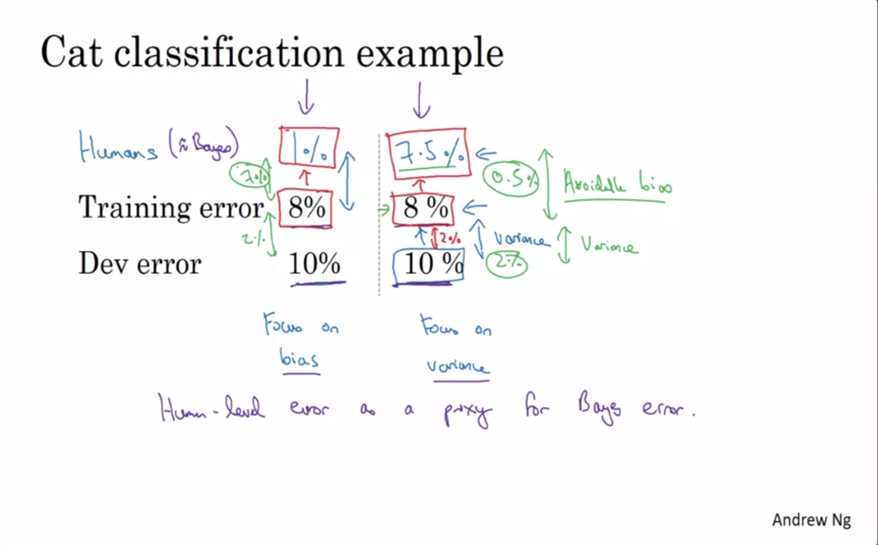

Look for the gaps! Same training and dev error can have different interpretations depending on human error. In this example we assume that bayes error is very close to human-level error (e.g. for computer vision tasks).

In the example on the left, the training error seems quite high.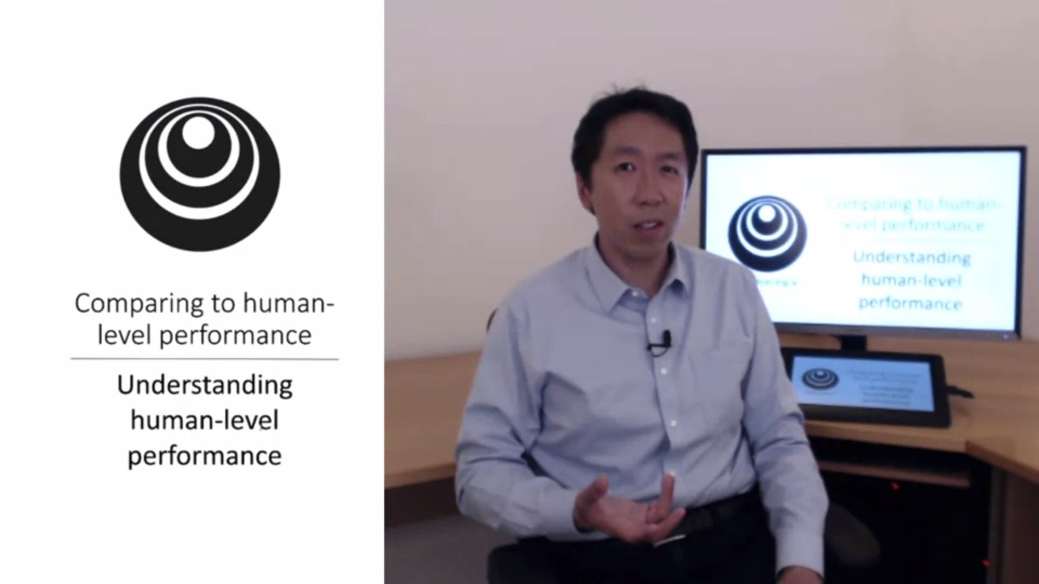

Sometimes this term is used casually in research articles. How can

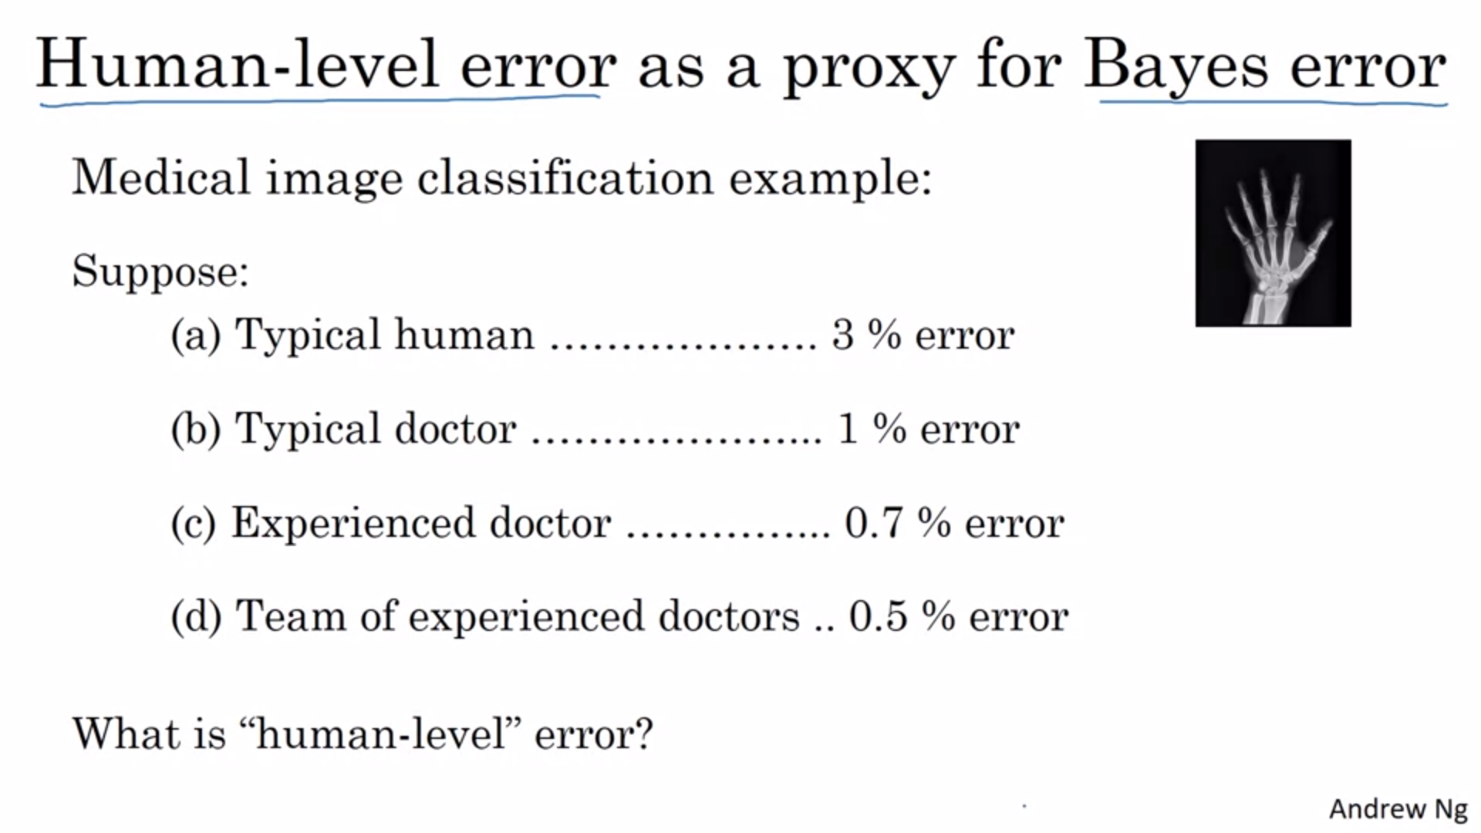

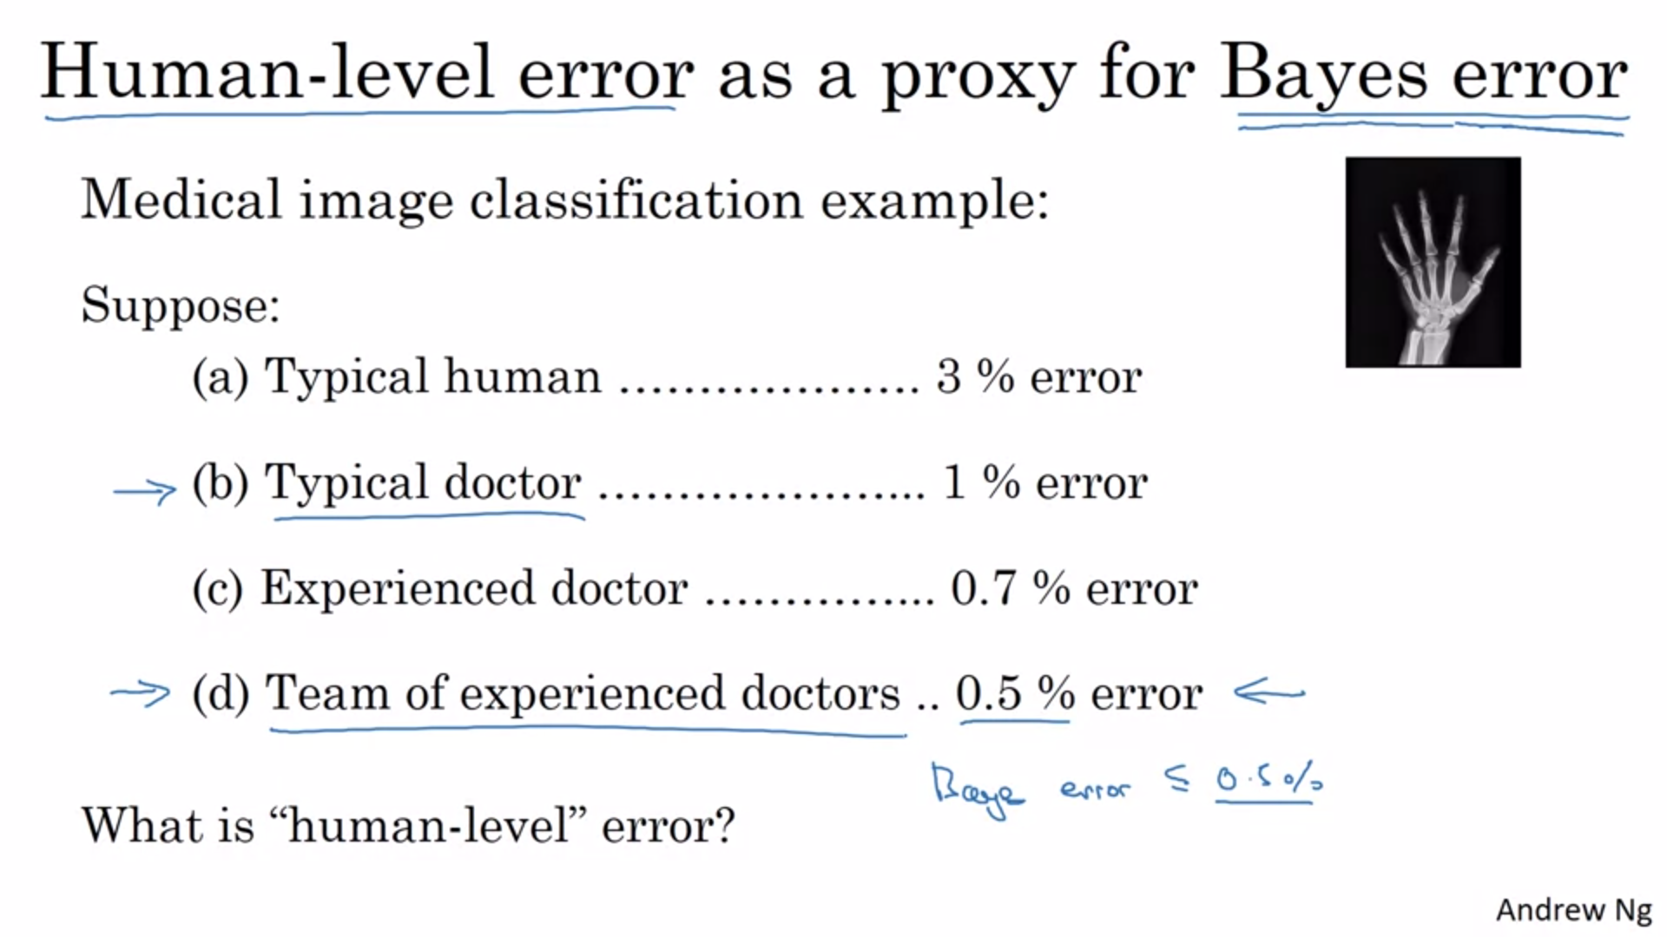

Maybe the system is already good enough for deployment if it surpasses the performance of a typical doctor.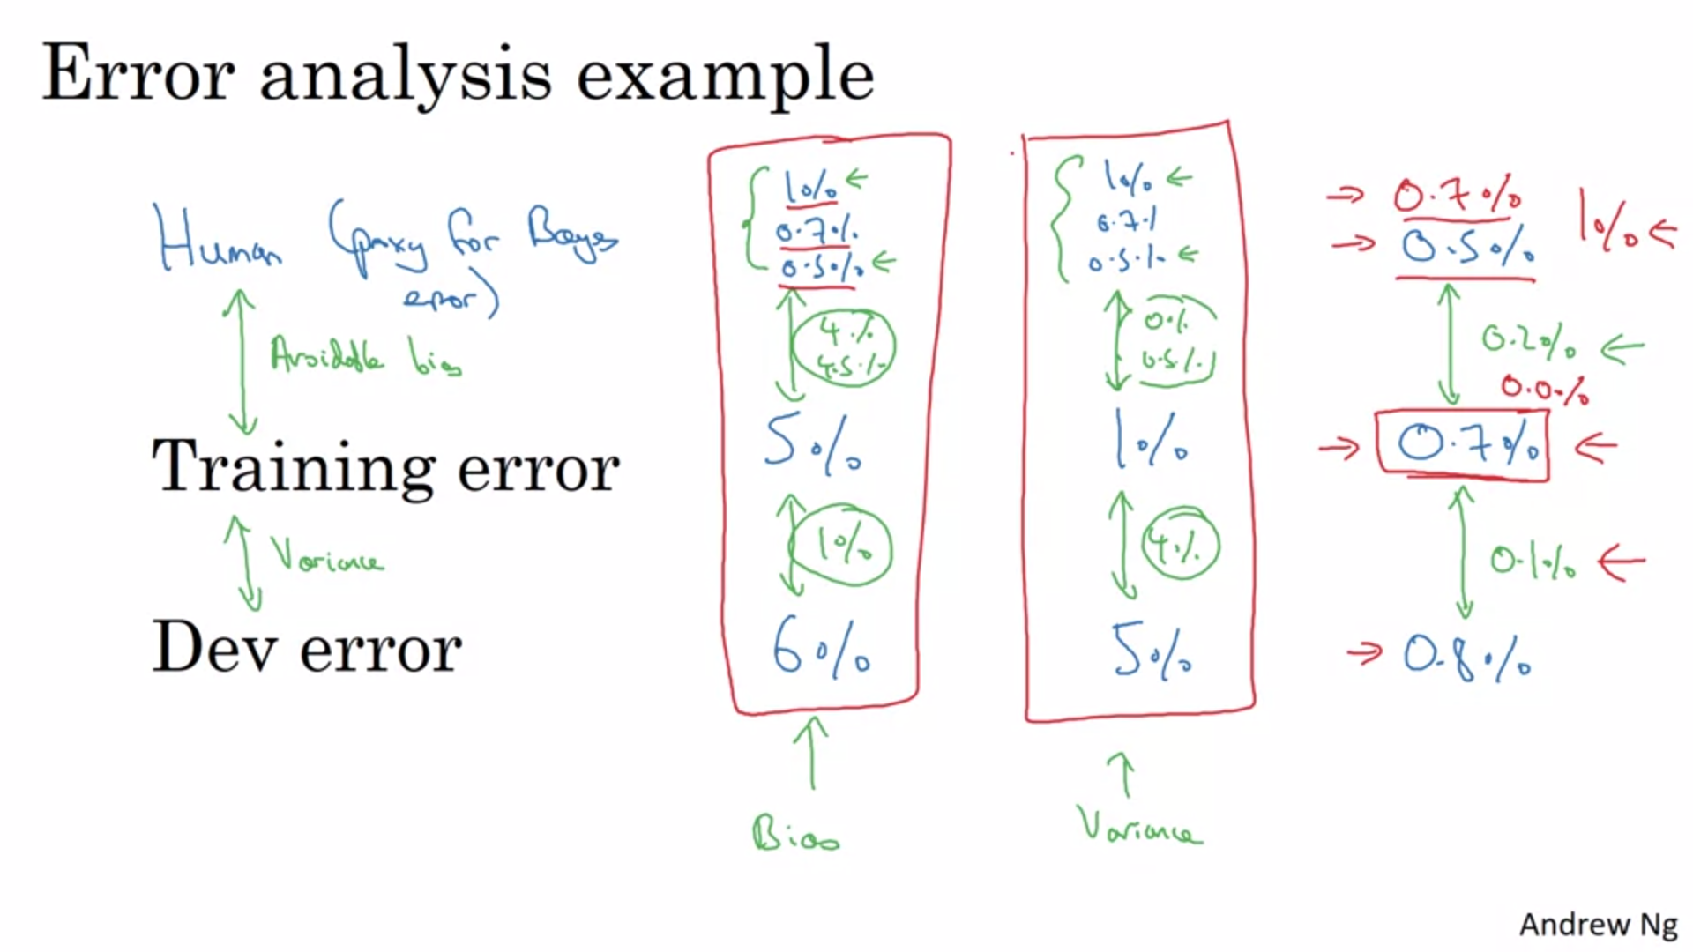

In the first two examples it does not matter which one you take as bayes error. You would reach the same conclusion. In the third example it does matter.

Again: making progress gets harder as you approach human-level error. It is harder to tease out the bias and variance effects.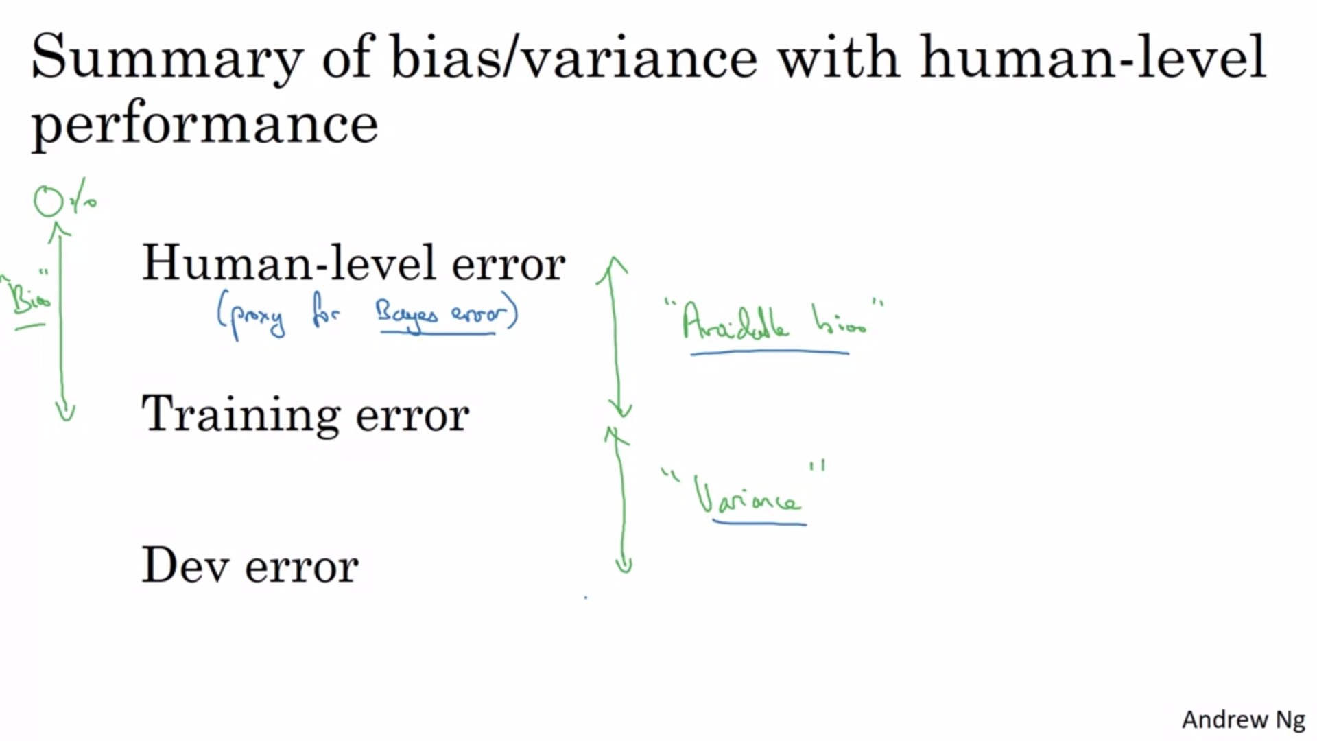

In earlier courses we called bias the difference to 0. Now we know better. We can make better decisions regarding whether to pursue bias or variance reduction tactics.

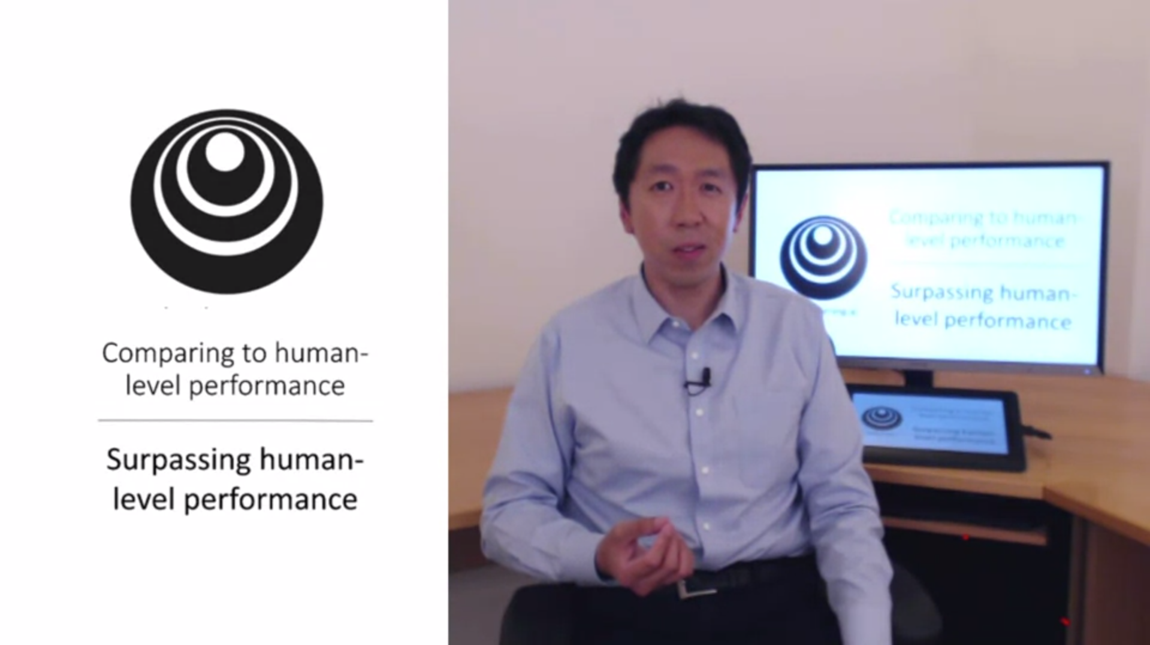

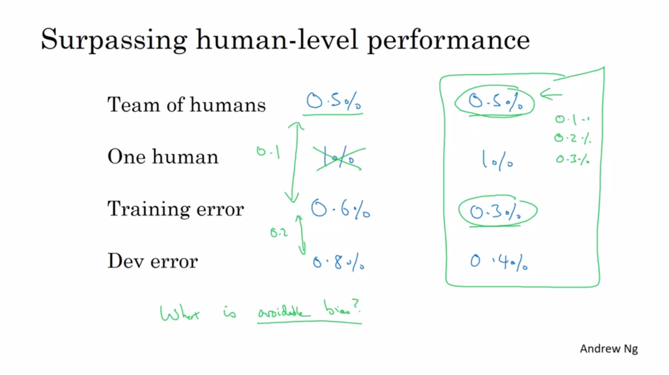

This is an exciting thing to achieve often times.

Left side: avoidable bias: 0.1; avoidable Variance: 0.2

Right side: not enough information to decide whether to reduce bias or variance -> slower progress. You can still make progress, but some tools are not available anymore.

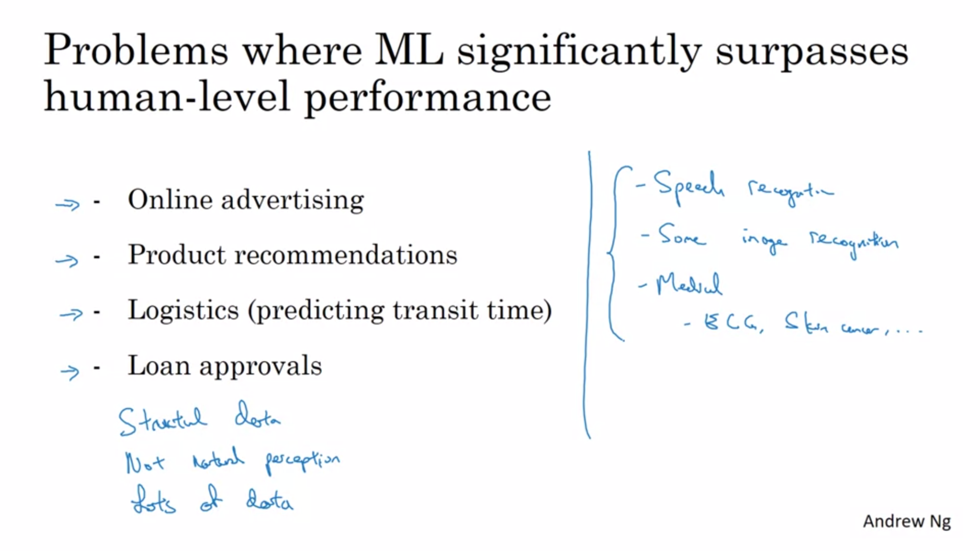

All the examples on the left side learn from structured data. Humans are better at natural perception tasks.

The best systems for these applications have looked at much more data than any human.

But there are also speech recognition and computer vision systems that have surpassed human-level performance. But it was harder for computers to get there.

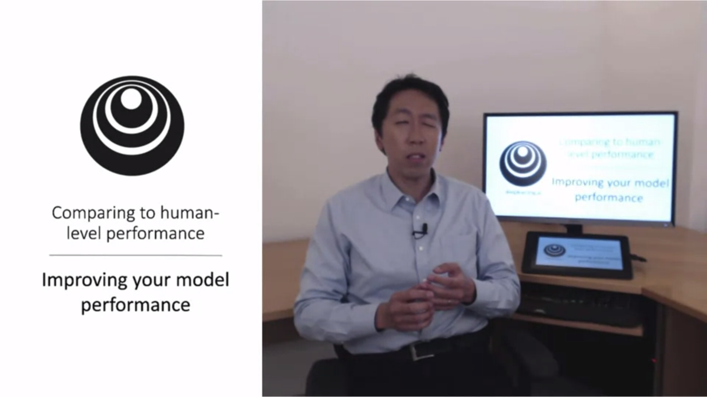

Let’s put everything together.

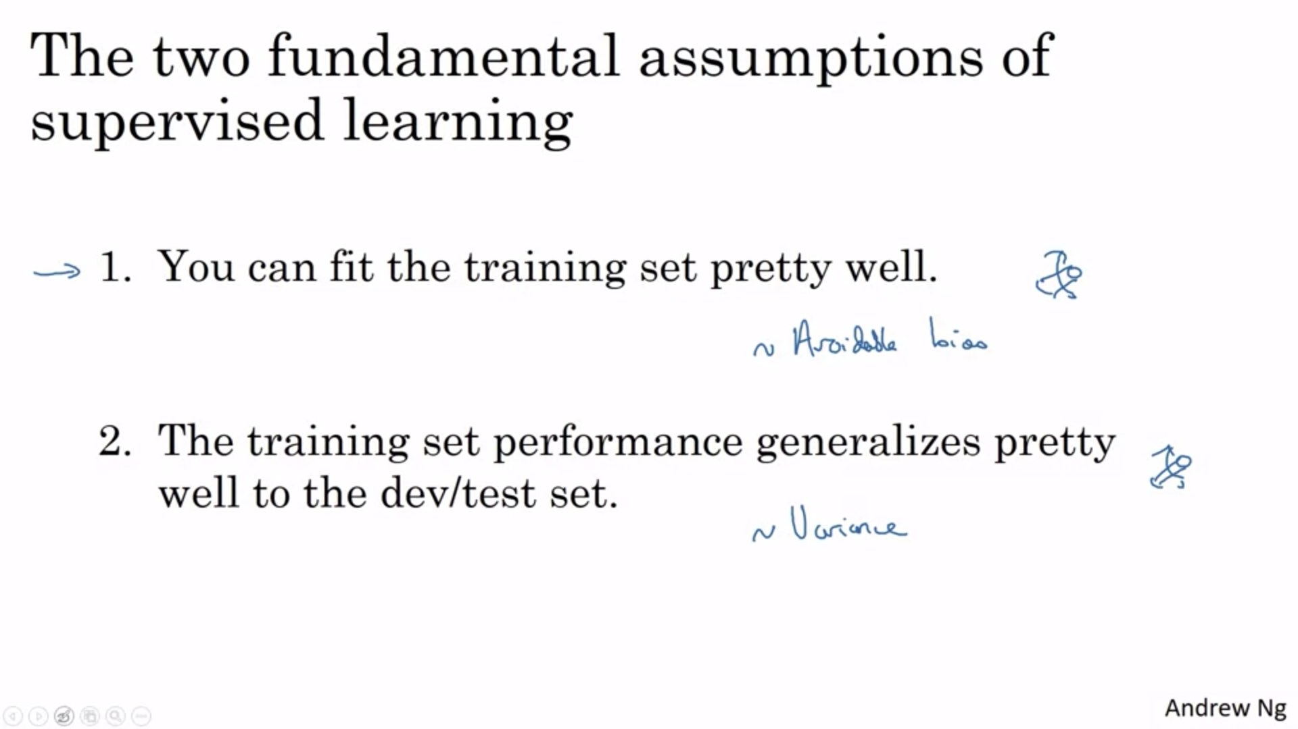

In the spirit of orthogonalization there are separate things that you can use for step 1 and 2.

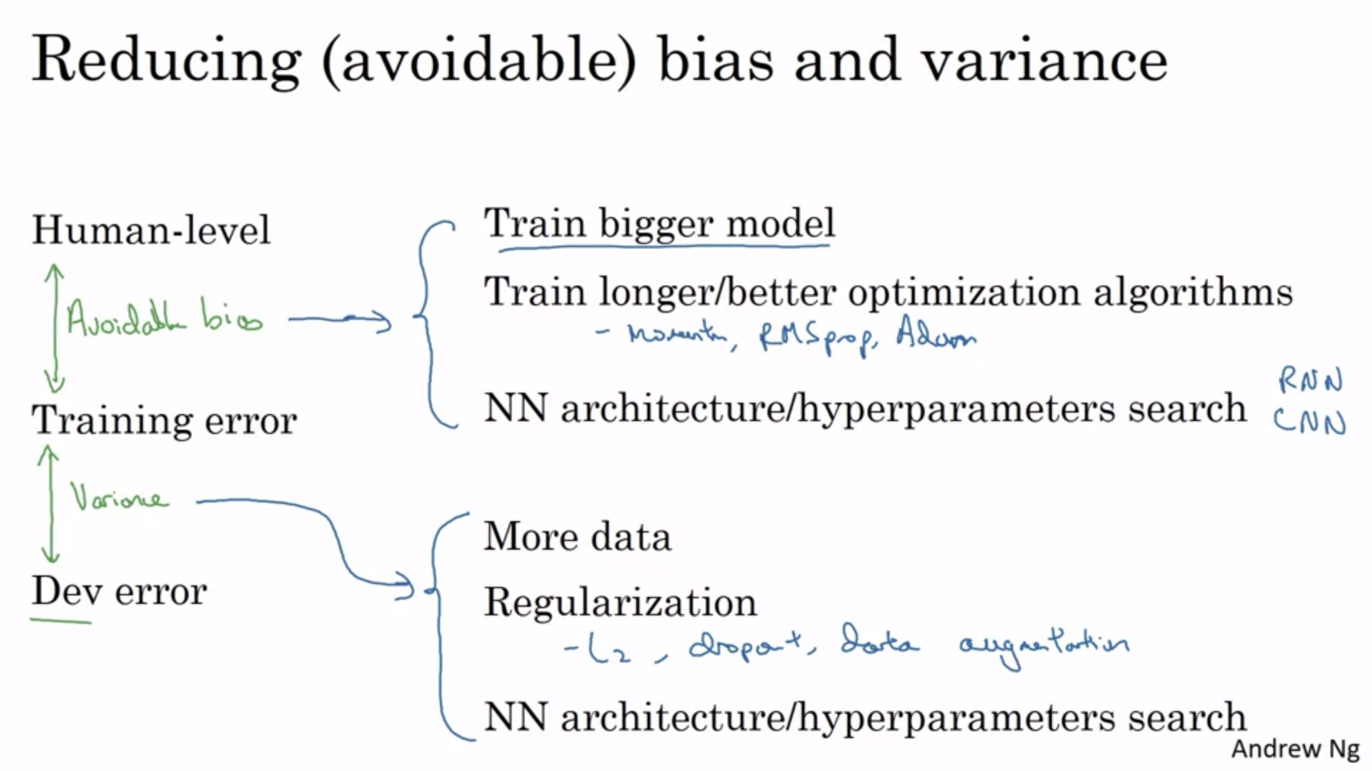

Human-level is the proxy for bayes error.